The new issue of Civic Practices is out

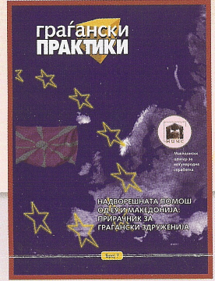
The Macedonian Centre linked to assistance, about Macedonian has limited access
For International Coope- managing funds, EU project to the EU funds’ sources. Tom-
ration issued the new edi- cycle and financial instrum- orrow this situation will change.
tion of Civil Practices, ents of EU and other useful MCIC prepared this manual in
This time in the form of a information. Order information to provide
Manual titled ‘’Foreign In the period between 1992 more information to the civil or-
Assistance from EU and to 2003 Macedonian received ganisations about how EU for-
Macedonian’’. The manual around 606 million Euro in the eign assistance functions and
contain useful information form of assistance from the Eu- how they can access it.
about EU institutions ropean Commission. To day

